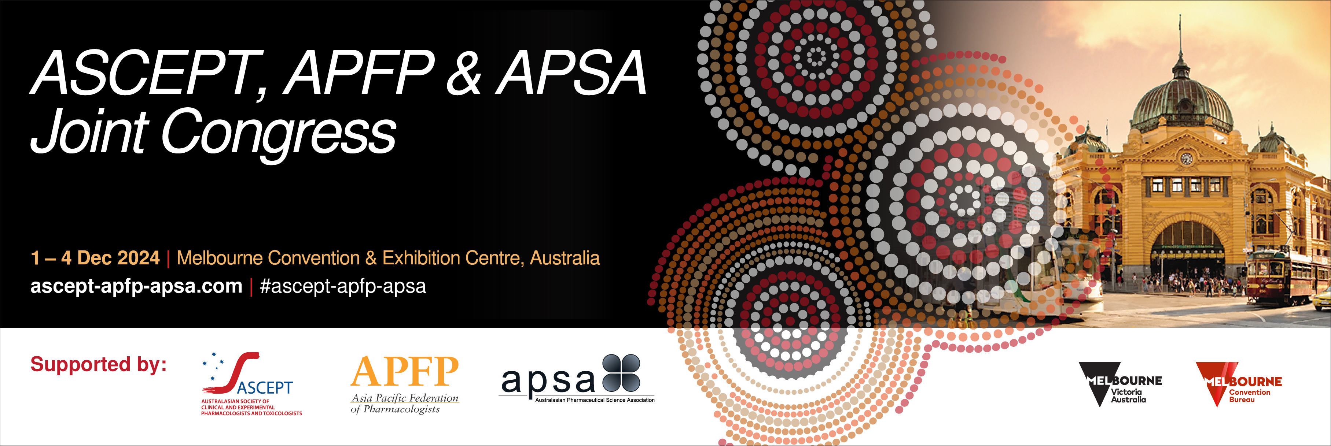

**Call for WORKSHOP PROPOSALS**

Submission is now open for proposals for workshops to be presented at the ASCEPT, APFP & APSA Joint Congress to be held from 1 – 4 December, 2024 in Melbourne, Australia. The Joint Congress brings together the leading clinical and experimental pharmacologists, pharmacists and toxicologists from the Asia-Pacific region; we, therefore, encourage topics that align with the shared interests of ASCEPT, APFP and APSA, where possible.

ASCEPT, APFP and APSA recognise the diversity of their membership and are committed to the values, attitudes and application of the principles of equity, diversity and inclusion to create a collegial, collaborative and successful professional community. The Joint Congress is committed to achieving equity and inclusion through balancing representation across workshop proposals in alignment with the diverse membership composition. Your application should describe aspects of equity, diversity and inclusivity (EDI) with the selection of chairs and speakers, including the proportion of male and female contributors, the career level (early, mid, senior), diversity of geographical locations, minority group representation etc. Download the ASCEPT policy [here](https://www.ascept.org/equity-diversity-and-inclusion-policy/).

The deadline for submitting workshop proposals is **Monday 5 February 2024.**

### **Workshop format**

The ASCEPT, APFP & APSA 2024 Organising Committee encourages the submission of *innovative and interactive* workshop proposals that take advantage of less formal formats.

Workshops will be restricted to a fixed length of two hours and are scheduled to run on Sunday, 1 December 2024. The number of available slots is limited and the final composition will be decided by the ASCEPT, APFP & APSA 2024 Organising Committee. Please note that ASCEPT, APFP & APSA will only provide the venue and required audio visual equipment. No other equipment and catering will be supplied, unless organised and paid for by the workshop organiser.

### **Meeting registration and travel expenses**

If your proposal is successful, the workshop applicant, chairperson and speakers will be requested to register for the Joint Congress. Workshop attendance will only be offered to those who have registered for the full Joint Congress.

ASCEPT, APFP & APSA members, including the workshop applicant, chairperson/facilitator and any speakers, are required to fund their own registration and travel expenses. Non-member speakers may be offered a single day complimentary registration at the discretion of the Organising Committee.

### **Instructions for the preparation of your workshop proposal**

Proposals must include sufficient supporting material to permit the Organising Committee to evaluate the quality of and potential interest in the workshop. Workshop proposals are to be submitted using the application form by **Monday 5 February 2024. Please upload your application via** <https://expertevents.eventsair.com/ascept-apfp-apsa-2024/ascept-apfp-apsa-workshop-submission-portal>

### **After the submission**

The ASCEPT, APFP & APSA 2024 Organising Committee will rank all submitted proposals according to quality, breadth of interest, interactive format and adherence to EDI principles. Submissions that follow a workshop format are encouraged. Applicants will be advised via email whether or not their workshop proposal has been accepted by **Wednesday, 21 February 2024.**

**Confirmation of workshop program and key participants**

### Successful applicants will be required to submit their final program, including any speaker and chairperson/facilitator names, to the meeting secretariat via email to [ascept-apfp-apsa@expertevents.com.au](mailto:ascept-apfp-apsa@expertevents.com.au) by **Friday 8 March 2024.**

### 

Proposal for ASCEPT–APFP-APSA workshop

**Please complete all details below and submit your application by Monday 5 February 2024.**

**Please upload your application via**

<https://expertevents.eventsair.com/ascept-apfp-apsa-2024/ascept-apfp-apsa-workshop-submission-portal>

|  |  |  |  |
| --- | --- | --- | --- |
| **Workshop proposer’s details** | | | |
| **Name:** |  | | |
| **Affiliation:** |  | | |
| **Address:** |  | | |
| **Phone:** |  | **Email:** |  |

|  |  |
| --- | --- |
| **Workshop details** | |
| **Workshop title:** |  |
| **Outline the purpose/aims of the workshop – this will be used as the abstract used in the program (100-200 words). Include a description of the anticipated audience.** |  |
| **Provide a draft timetable of the format of the workshop, noting that each workshop is capped at 2 hours.** |  |
| **Brief statement about how your proposed workshop addresses the goals of equity, diversity and inclusion to meet ASCEPT, APFP & APSA’s commitment to balancing representation across their activities in alignment with the diverse composition of their membership**  **(e.g. through the consideration of workshop speakers, chairs etc.).** |  |
| **Potential sources of sponsorship (list organisation name and contact details and advise who will contact them). It is expected that workshop organisers will seek support for invited speakers.** |  |
| **Are there any special requirements you would like to discuss with the conference organisers Expert Events? e.g. round table format vs symposia seating. Note that additional charges may apply for room set-up.** |  |

|  |  |
| --- | --- |
| **Proposed Chairperson(s)/Workshop Facilitators:** | |
| Name (including academic title): |  |
| Position title: |  |
| Affiliation: |  |
| Country: |  |
| Email: |  |
| Society member? | 🗆ASCEPT 🗆APSA 🗆APFP-indicate society______________ 🗆NON-MEMBER |
| **Agreement:** | 🗆 This chairperson has agreed to participate in the workshop if accepted for the program. |

**\*If your workshop will include specific participants in panel discussions or short talks, please list them below\***

|  |  |
| --- | --- |
| **Proposed Participant 1:** | |
| Name (including academic title): |  |
| Position title: |  |
| Affiliation: |  |
| Country: |  |
| Email: |  |
| Draft presentation title, if applicable: |  |
| Society member? | 🗆ASCEPT 🗆APSA 🗆APFP-indicate society______________ 🗆NON-MEMBER |
| **Agreement:** | 🗆 This person has agreed to participate in the workshop if accepted for the program. |

|  |  |
| --- | --- |
| **Proposed Participant 2:** | |
| Name (including academic title): |  |
| Position title: |  |
| Affiliation: |  |
| Country: |  |
| Email: |  |
| Draft presentation title, if applicable: |  |
| Society member? | 🗆ASCEPT 🗆APSA 🗆APFP-indicate society______________ 🗆NON-MEMBER |
| **Agreement:** | 🗆 This person has agreed to participate in the workshop if accepted for the program. |

|  |  |
| --- | --- |
| **Proposed Participant 3:** | |
| Name (including academic title): |  |
| Position title: |  |
| Affiliation: |  |
| Country: |  |
| Email: |  |
| Draft presentation title, if applicable: |  |
| Society member? | 🗆ASCEPT 🗆APSA 🗆APFP-indicate society______________ 🗆NON-MEMBER |
| **Agreement:** | 🗆 This person has agreed to participate in the workshop if accepted for the program. |

*Include additional boxes as required.*